- Create a database named company and a table named employees with the following fields:
- id (INT, Primary Key, Auto Increment)
- name (VARCHAR(100))
- position (VARCHAR(100))
- salary (DECIMAL(10,2))
- date_of_joining (DATE)
Ans.
create database company;
use company;
create table employees(
id INT Primary Key,
name varchar(100),
position varchar(100),
salary DECIMAL(10,2),
date_of_joining DATE);
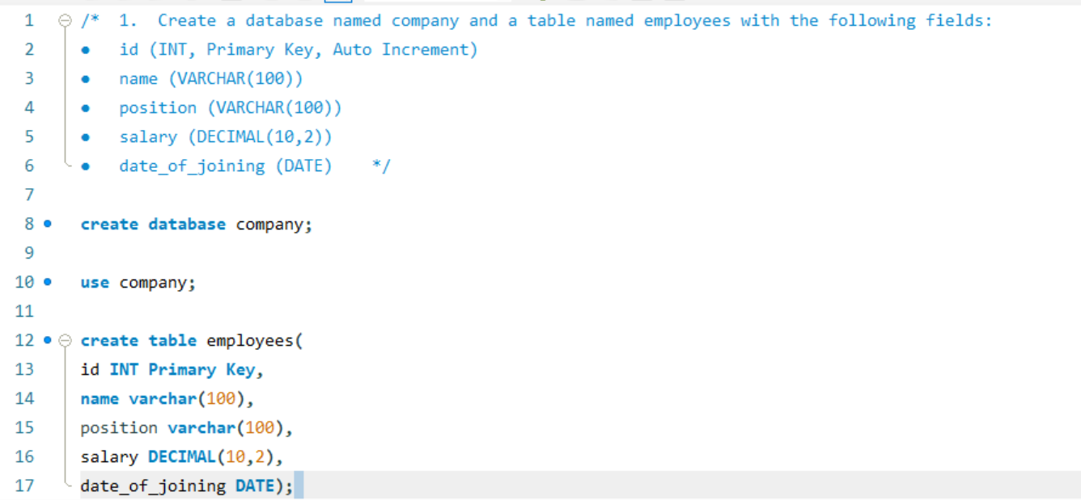

- Insert the following data into the employees table:
- John Doe, Manager, 55000.00, 2020-01-15
- Jane Smith, Developer, 48000.00, 2019-07-10
- Alice Johnson, Designer, 45000.00, 2021-03-22
- Bob Brown, Developer, 50000.00, 2018-11-01
Ans.
INSERT INTO employees (id, name, position, salary, date_of_joining ) VALUES
(1, "John Doe", "Manager", 55000.00, "2020-01-15"),
(2, "Jane Smith", "Developer", 48000.00, "2019-07-10"),
(3, "Alice Johnson", "Designer",45000.00, "2021-03-22"),
(4, "Bob Brown", "Developer", 50000.00, "2018-11-01");
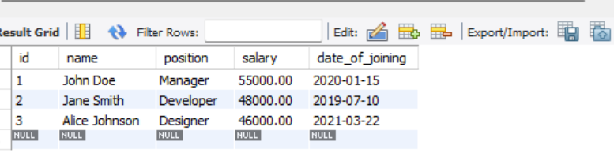

- Write a query to retrieve all employees who are Developers.

select*from employees where position="Developer";
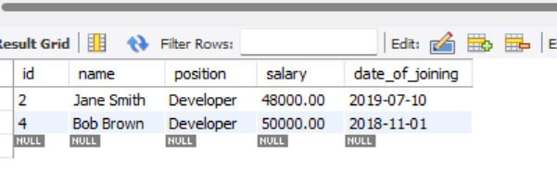

- Write a query to update the salary of Alice Johnson to 46000.00.
set sql_safe_updates=0;
update employees
set salary=46000.00 where name="Alice Johnson";
select*from employees;
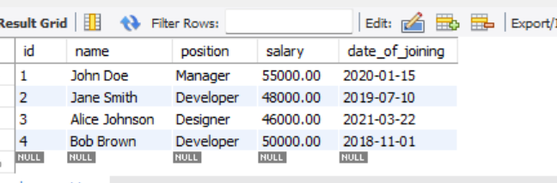

- Write a query to delete the employee record for Bob Brown.
delete from employees
where name="Bob Brown";
select*from employees;
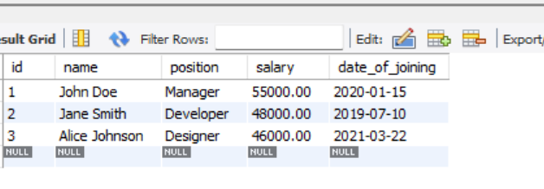

- Write a query to find the employees who have a salary greater than 48000.

select*from employees
where salary>48000 ;

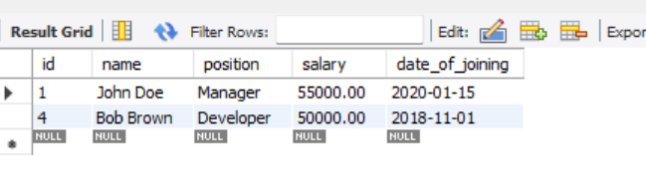

- Write a query to add a new column email to the employees table.
alter table employees
add email varchar(100);
select * from employees;

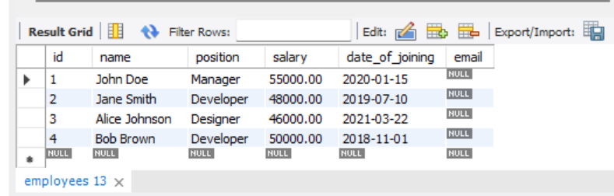

- Write a query to update the email for John Doe to john.doe@company.com.
update employees
set email="john.doe@company.com."
where name="John Doe";
select*from employees;

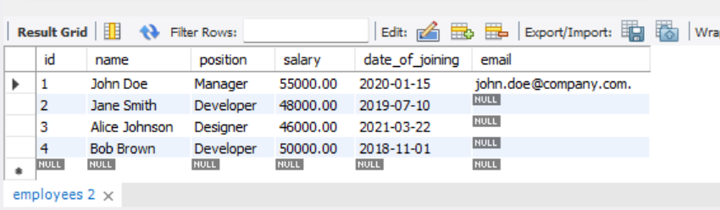

- Write a query to retrieve only the name and salary of all employees.
select name,salary
from employees;

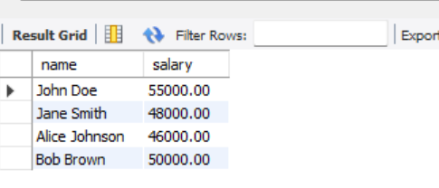

- Write a query to count the number of employees who joined after January 1, 2020.
select *from employees
where date_of_joining>"2020-01-01";

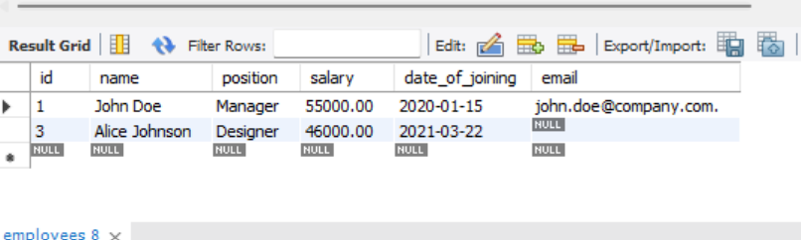

- Write a query to order the employees by salary in descending order.
select name,salary
from employees
order by salary desc;

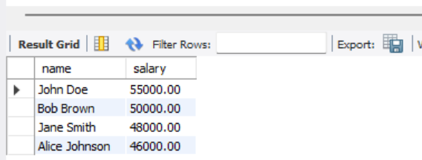

- Write a query to order the employees by salary in descending order.

Alter table employees
drop column email;
select * from employees;

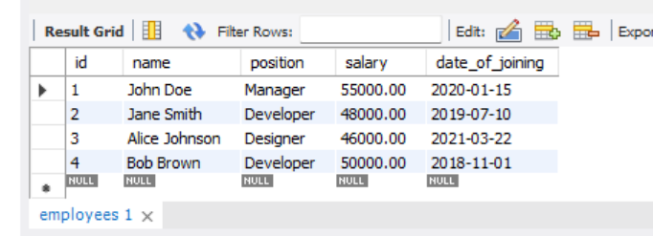

- Write a query to find the employee with the highest salary
select* from employees
order by salary desc
limit 1;

